(Solved) Lonsdor K518ISE update error abnormal machine and try to restore

One customer feedback: when he tried to update Lonsdor K518ISE key programmer, he got error: "The machine is abnormal, try to restore, scm file lost" shown as bellow.
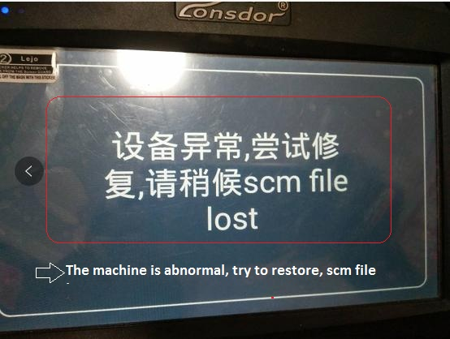
Solution:
1. Press the "Settings" button and "Back" button at the same time.
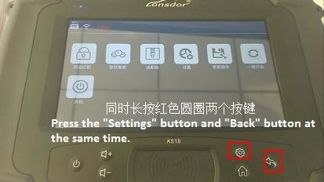
2. Uninstall the current APK until you see "APK is uninstalled successfully".
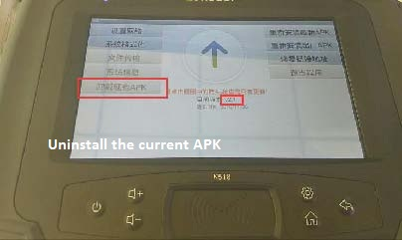
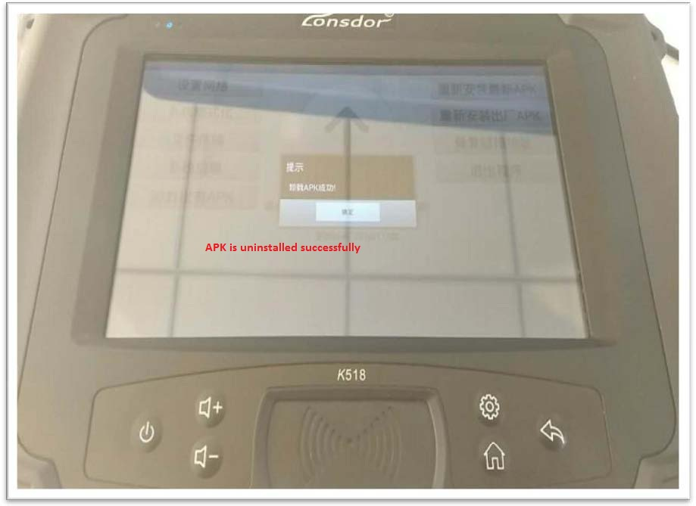
3. Tap "Online update (New), you can tap the circle to check if there is newest updates.
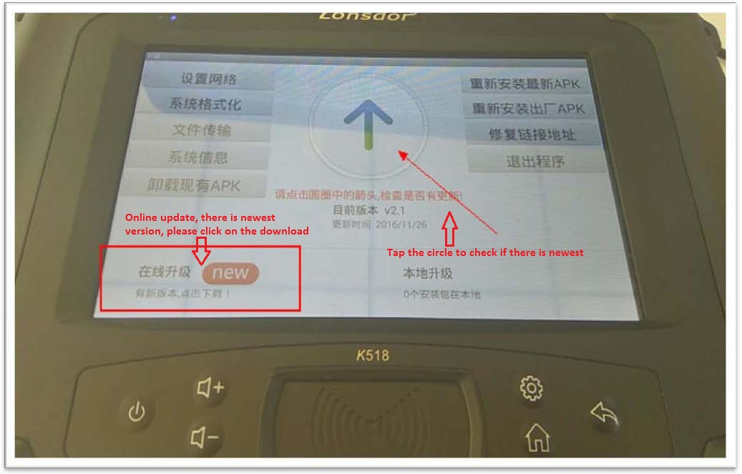
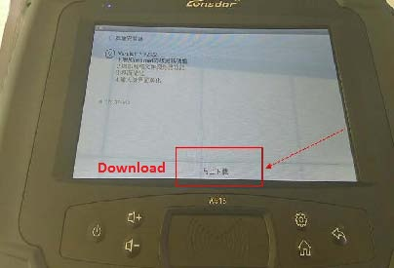
4. Install and it will take you a longer time, during this waiting process you can do something else. After installation complete, reboot the machine and you are asked to set the WIFI and tap the "Update" option, if the update failure, change another Wifi or refer to the WIFI settings file to change domain name.

If you get the same prompts shown as below, then please follow the below guide to operate.
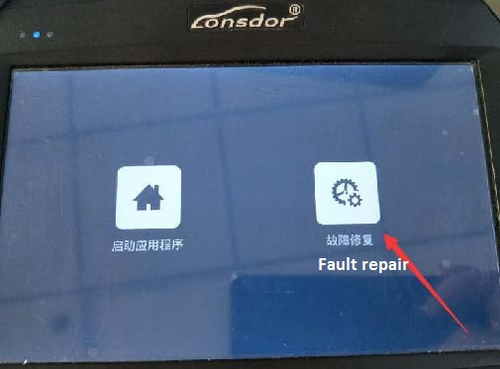
1). Tap "Fault repair".
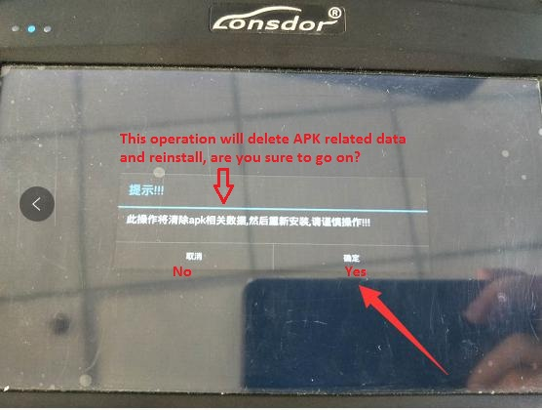
2). Get message "This operation will delete APK related data and reinstall, are you sure to go on?"
Tap "Yes".
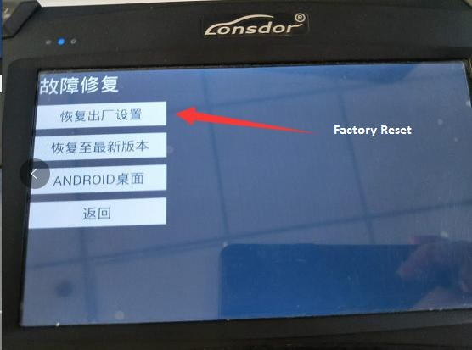
3). Tap "Factory reset".
4). Install complete, tap "Back".
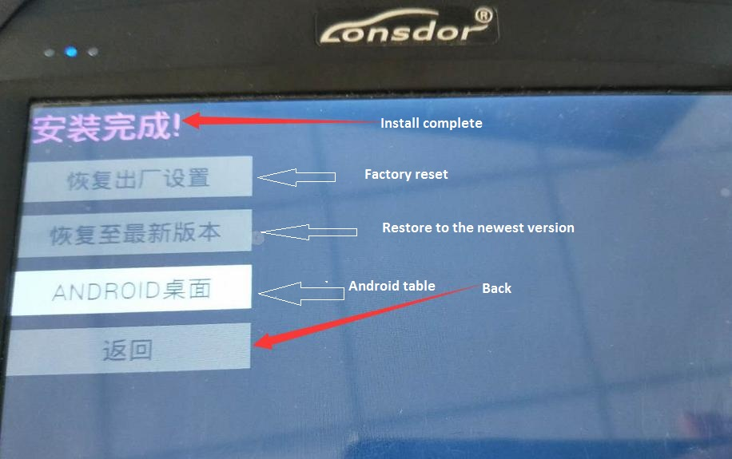
5). Tap "Start the application".
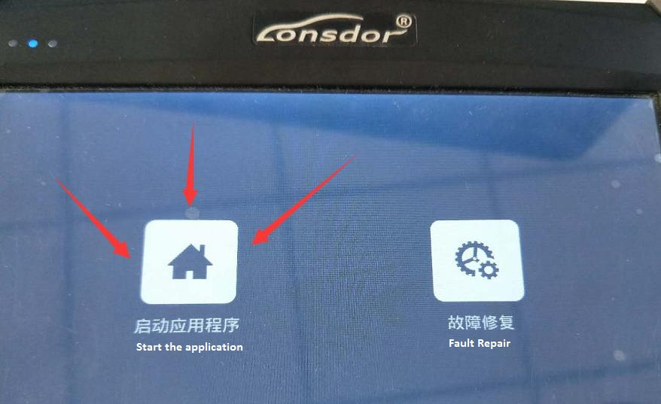
6). Please enter 6-digit power-on password.
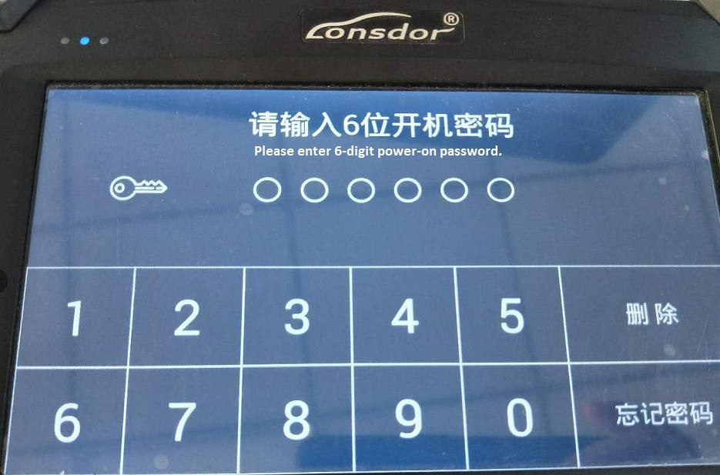
7). Tap "Update".
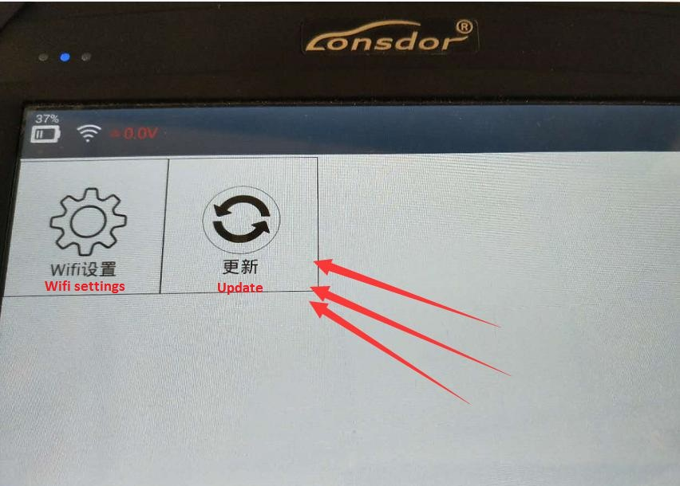
Done.

